4.8 Centers of Gravity Using Multiple Integrals Worksheet

- A lamina occupies the region . Find the mass and center of mass of the lamina if its density at the point is given by .

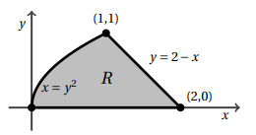
- Consider the region R pictured to the right. Determine the center of mass of this region if the region has a density determined by

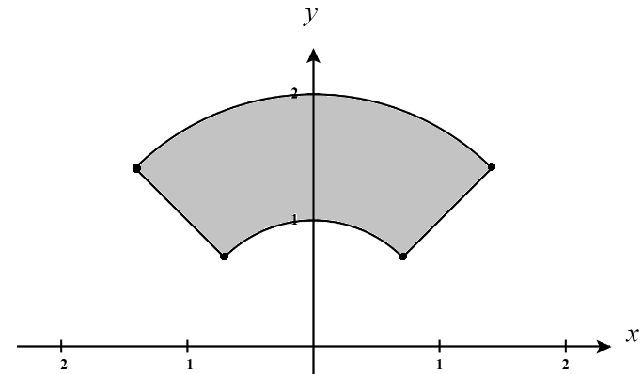
- Consider the region R pictured to the right. Determine the center of mass of this region if the region has a density determined by

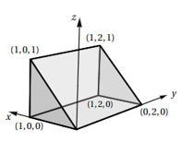
- Consider the solid region E shown to the right. Suppose the density at any point within E is given by . Determine the center of mass of the of E.

- Let E be the portion of the positive octant which is inside the unit sphere. Determine the center of mass of the E assuming it has a density function .

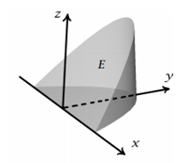
- Consider the region E shown below which is bounded the xy-plane, the plane and the surface . Determine the center of mass of this cone assuming it has a density function .

